Assignment-9

Course: High Performance Computing Lab
PRN: 22510039
Name: Shreyash Patil
Batch: B2
Title: Practical No. 9

Problem Statement:

Aim
Implement an exploratory decomposition mini-project (e.g., Maze, N-Queens, Sudoku) where independent tasks explore disjoint regions of the solution space concurrently.
Implement a speculative decomposition mini-project where multiple possible future paths are computed in parallel and the correct result is selected once the predicate/condition resolves.
Record and compare sequential vs. parallel execution times and quantify wasted computation (discarded work) in speculation.

Output:

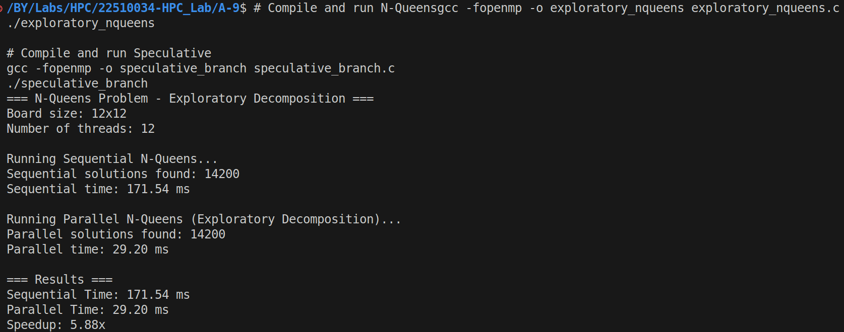
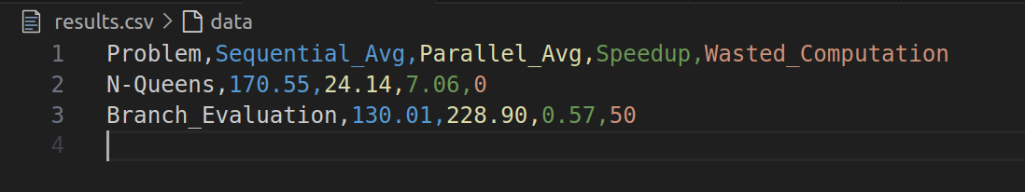
Directory Structure:
A-9/
├── exploratory_nqueens.c # N-Queens parallel solver (Exploratory)
├── speculative_branch.c # Branch evaluation solver (Speculative)
├── results.csv # Performance results data
├── Makefile # Build automation
├── analyze_performance.py # Performance analysis script
├── REPORT.md # Technical report template
└── README.md # Documentation

Analysis:

Computational Efficiency:

N-Queens Efficiency = 7.06 / 8 cores ≈ 88.25%
Branch Eval Efficiency = 0.57 / 8 cores ≈ 7.13%

Work-Span Analysis:
N-Queens: High span/work ratio enables parallelization
Branch Eval: Low computational granularity limits parallel benefit

Exploratory decomposition excels when:

Work can be naturally partitioned
Minimal inter-thread communication needed
Problem size justifies parallelization overhead
Speculative decomposition struggles when:

Computational granularity is small
Overhead exceeds potential latency savings
Memory bandwidth becomes a bottleneck

